

YORKVILLE POLICE DEPARTMENT

Monthly Report
July 2025

Chief of Police James Jensen
651 Prairie Pointe Dr
Yorkville, IL 60560

MISSION STATEMENT

The mission of the Yorkville Police Department is to work in partnership with the community to protect life and property, assist neighborhoods with solving their problems, and enhance the quality of life in our city.

ORGANIZATIONAL CHART

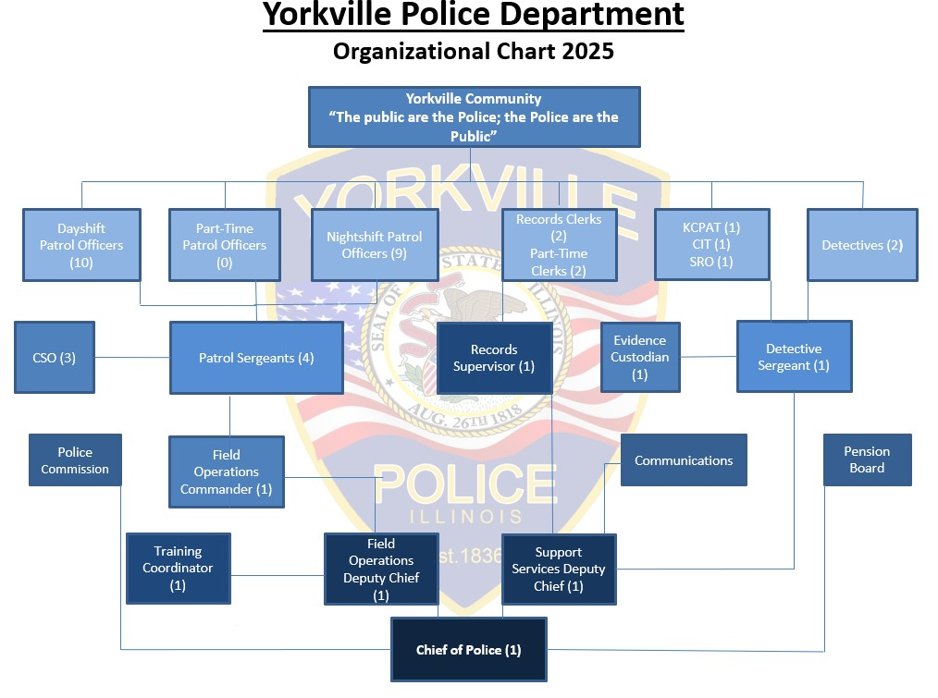

PERSONNEL INFORMATION
Employees
 | July 2024 | July 2025
Sworn Officers | 33 | 33
Clerical | 3 | 3
Part- Time Evidence Custodian | 1 | 1
Part-Time Training Coordinator | 1 | 1
Part-Time Community Service Officers | 2 | 3
Part-Time Clerical | 2 | 2
Total | 42 | 43

Overtime Hours Worked
 | July 2025 | 2025 Total
Call Outs / Stay Over | 17 | 97.25
Clerical | 0 | 0
Community Service | 0 | 0
Court | 7.5 | 28.5
Grants | 0 | 0
HIDTA CPAT | 0 | 51
HIDTA CIT | 10 | 103
ILEAS Deployments | 0 | 0
Investigations | 8 | 69
Meetings | 5 | 14.5
Miscellaneous (* FTO) | 11 | 31
School Events | 0 | 2.5
School Liaison Officer | 0 | 0
Special Event Ribs on the River | 0 | 0
Special Event Summer Solstice | 0 | 0
Special Event Yorktober Fest | 0 | 0
Special Event Fourth of July | 30 | 30
Street/Shift Coverage | 0 | 6.5
Training | 0 | 117.5
Water Park Details | 0 | 0
Misc. Details | 11 | 25.75
OIC | 0 | 10
Total Overtime Hours | 99.50 | 586.50
Total Regular Hours | 5,399 | 39,473.5

Benefit Time Used
 | July 2025 | 2025 Total
Vacation | 778 | 2,419
Paid Time Off | 0 | 24
Holiday | 248 | 1,496
Holiday Pay / Double-time | 183.5 | 404
Sick | 71 | 1,223
Compensatory time taken | 131 | 930
Floating Holiday | 58 | 394
Straight Time Pay – Training | 0 | 454.25
Total Hours | 1,469.5 | 7,344.25

Compensatory Time Earned
 | July 2025 | 2025 Total
Total | 330.625 | 1,964.945

COMMUNITY POLICING INITIATIVES
Community Information
Facebook Post (7/1/25): ASK AN OFFICER!
Ever wonder what it’s really like inside a police car? Or how fast we can run wearing all this gear? Maybe you’ve always wanted to ask, “Do you actually like donuts?” Now’s your chance!
We’re inviting our Yorkville community—especially our Yorkville youth—to ask the questions you’ve always been curious about but never got the chance to ask. No question is too big, too small, or too out-of-the-box! Send your questions to AskYPD@Yorkville.il.us, and we’ll have our officers answer some of the best ones in an upcoming video!
Let’s have some fun and maybe learn a little. We want to keep building the strong community connections that make Yorkville a pretty great place to be and we thought this might be a fun opportunity to interact this summer.
We love good questions—just remember, be respectful please! TikTok roasts don’t count……unless they are really funny.

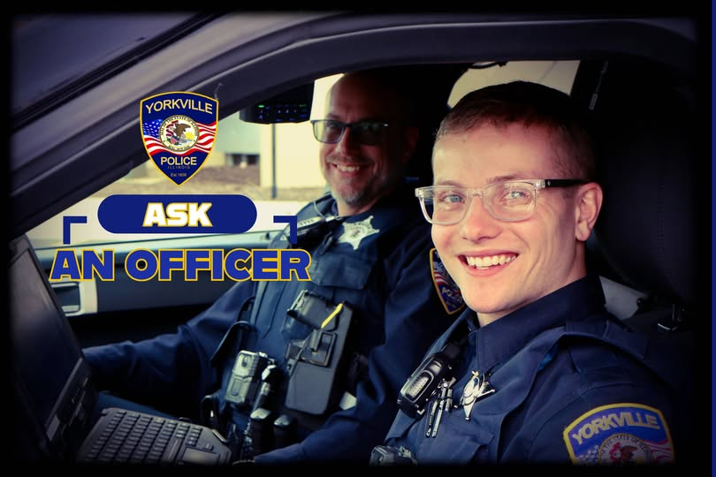
Facebook (7/9/25): Speed Study Update – Route 47
Our recent speed study of downtown Route 47 confirmed what many of you have been telling us — drivers are pushing the limit during early morning commute hours.
Based on this data, we’ll be focusing our enforcement efforts during those key hours between 5:00 AM and 8:00 AM.
Consider this your fair warning.
We would much rather have compliance rather than citations. Leave a few minutes early, ease off the gas — summer is meant for cruising, not racing — and help us keep the roads safe for everyone starting their day. Plus, sweet corn season is coming up, save your time and money for your favorite roadside stand!

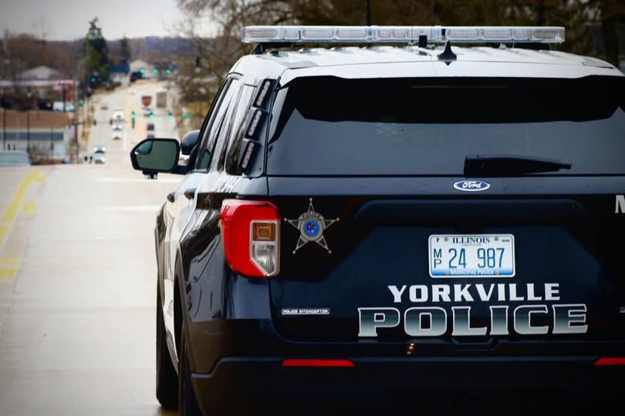

Facebook Post (7/15/25): Motorist Arrested for D.U.I. / Attempted Reckless Homicide
On Sunday July 13, 2025, at approximately 8:40 p.m., Yorkville Police were dispatched to a business on the 1500 block of Corneils Road. A witness was reporting a black Toyota pickup truck crashing into multiple vehicles and reportedly attempting to strike a pedestrian.
Upon arrival, officers located damaged property along with several damaged vehicles. The suspect vehicle had fled the scene prior to police arrival. A short time later, the Toyota was discovered approximately one mile east of the original scene, off the roadway in a ditch on Corneils Road. It appeared the driver had lost control of the vehicle.
Yorkville Police were assisted by the Plano Police Department and the Kendall County Sheriff’s Office in locating the vehicle and suspect.
The driver, identified as Thomas K. Betsinger (M/W, 50 years old, 3100 block of Buchanan Ln., Montgomery, IL), was located near the vehicle and taken into custody by Yorkville Police without further incident.
Betsinger was transported to the Kendall County Jail and booked on the following charges:
• One count of Aggravated Assault
• One count of Criminal Damage to Property
• One count of Attempted Reckless Homicide
• Two additional counts of Aggravated Assault
• One count of Driving Under the Influence of Alcohol
Preliminary investigation revealed surveillance video from the business which showed the suspect vehicle driving off the parking lot surface in what appears to be an intentional attempt to strike a pedestrian multiple times before crashing into two parked vehicles and fleeing the area.
Charges are not proof of guilt. The defendant listed in this release is presumed innocent and is entitled to a fair trial, at which it is the burden of the State to prove guilt beyond a reasonable doubt.



Facebook Post (7/20/25): Mill Rd/Tuscany Trl
The railroad crossing gates are down at the crossing. The railroad has been notified of the issue.

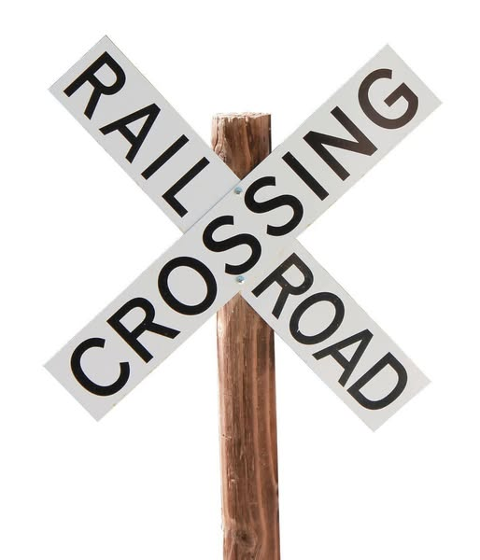

Facebook Post (7/29/25): Route 47 south of Route 71
***Final Update***
The vehicles have been cleared from the roadway. Please continue to use caution when traveling in the area due to construction. Thank you again for everyone’s patience. ￼

***Update***
One lane of traffic is currently open.
Yorkville Police are on the scene with a motor vehicle collision. The roadway is blocked in both directions for an unknown period of time. We will update the post when the roadway is open. Thank you for your patience.

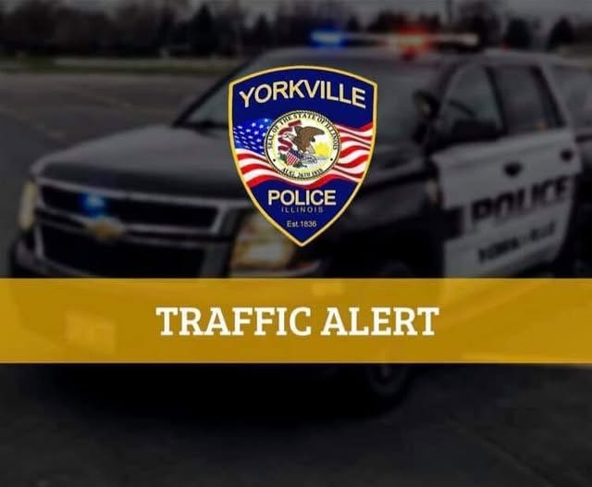

Facebook Posts
Facebook Post (7/2/25): Leave the “good stuff” to the pros!
You might have a Joe Dirt encyclopedia of fireworks knowledge and a rockin’ mullet to match—but let’s keep it safe this holiday weekend.
(But seriously) Before the holiday kicks off, YPD wants to remind everyone that Class 1.3G fireworks are prohibited in Yorkville. That includes anything that sounds like a cannon, launches like a missile, or makes your neighbor hit the deck.
We want everyone to have a fun, safe, and law-abiding holiday—so come enjoy our show on the 4th and “keep on keepin’ on.”

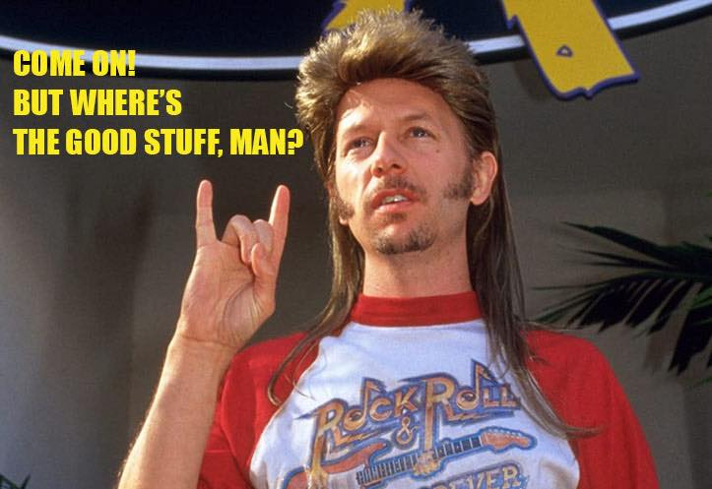
Facebook Post (7/3/25): We're excited to celebrate Independence Day with our Yorkville community tomorrow and wanted to share some information about our upcoming parade and fireworks planning. Take a look at these maps for times and road closure information.
For all event times, locations, and details be sure to visit:
https://www.yorkville.il.us/567/Independence-Day-Celebration
Let's make it a safe and fun filled weekend!

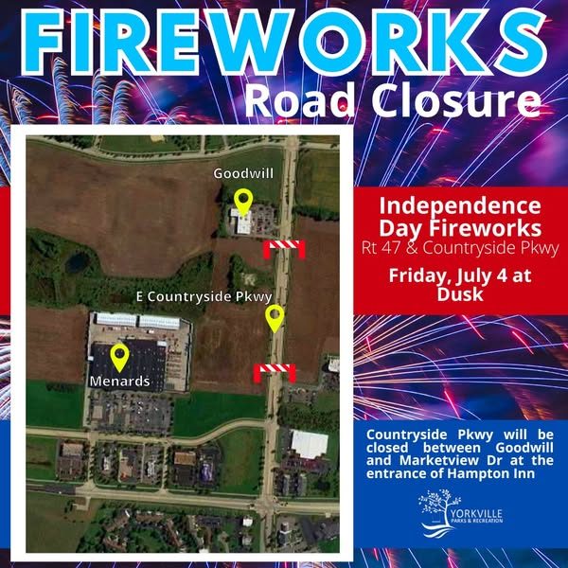

Facebook Post (7/4/25): Happy Birthday America!
Yorkville started Independence Day right with a great parade. YPD is wishing everyone a great 4th. Enjoy the BBQ and sun. We will see you tonight for fireworks!

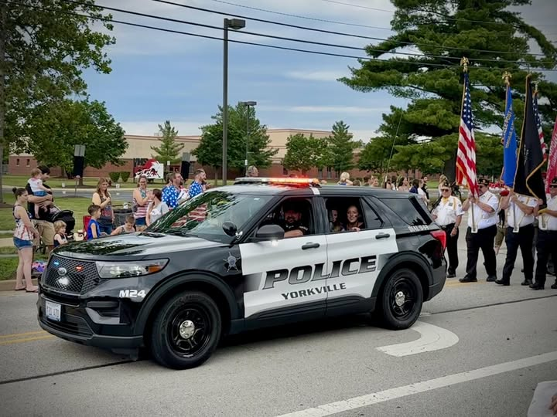


Facebook Post (7/11/25): Last night Officer Kolowski was honored by Bristol Kendall Fire Protection District for his life saving efforts on June 16. It's not every day you get to shake hands with someone who is alive because of your quick actions.
Officer Kolowski, we are proud of you. Mr. Stiles is with his family today because of you. What an incredible thing.

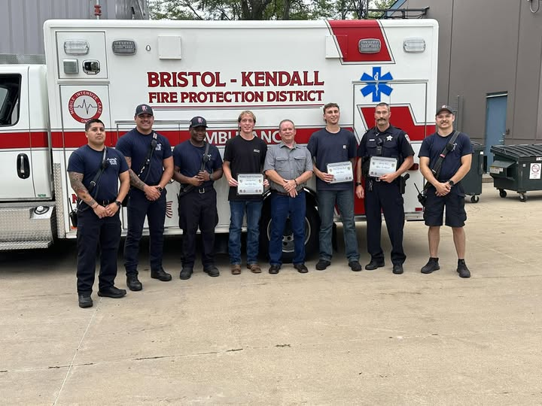

Facebook Post (7/11/25): See our latest TripAdvisor review as we tour our favorite Yorkville stands. Decoration was 10 out of 10 and the attitudes definitely match! Thank you to the lovely young servers who helped keep Officers Gerlach and Wade hydrated and happy this afternoon.

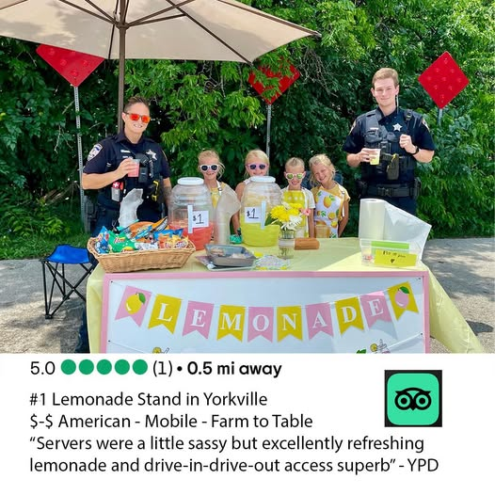

Facebook Post (7/14/25): This day in history...1947 to be exact.
The official creation of the Yorkville Police Department was signed and sealed by the Board of Trustees of the Village of Yorkville. Pretty cool to find our "birth certificate", makes for some interesting reading.
Apparently we have 77 candles to put on our donuts this morning! Here's to the past, present, and future of our city. We hope you have a great week, Yorkville.

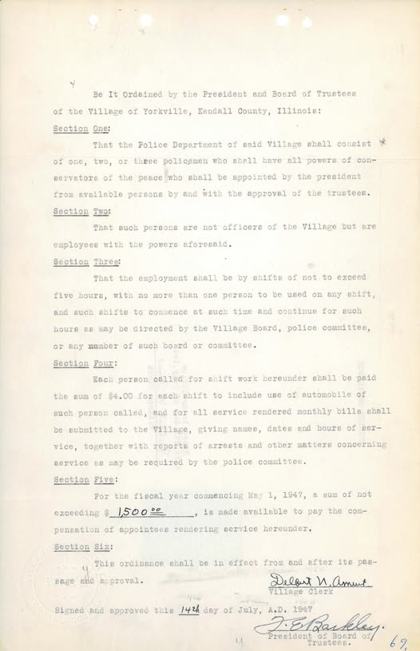

Facebook Post (7/18/25): Happy Friday Yorkville. We had the pleasure of visiting another lemonade stand and hanging with our young friends. Thanks for the refreshment’s fellas! Please see our latest review

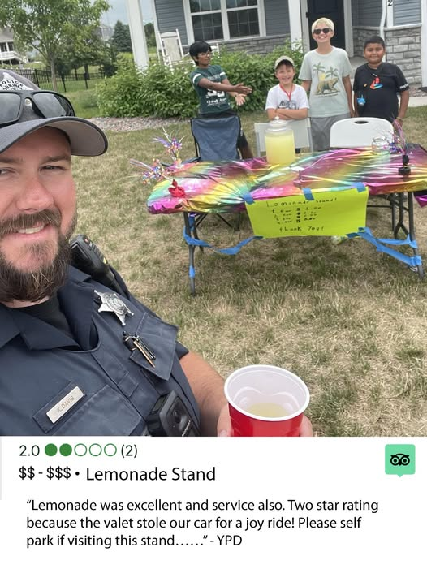

Facebook Post (7/21/25): This past Friday night, we had the privilege of attending the 40th Annual Respect For Law Banquet, hosted by the Kendall County Association of Chiefs of Police. It was a special evening to make much of our law enforcement professionals from across Kendall County, especially a few of the outstanding members of our YPD family.
We don’t always take time to honor the everyday commitment our officers and staff show to the Yorkville community—but we should. To our entire YPD staff, while we’ve come to expect excellence, we will never stop being grateful for it. We are PROUD of you. To our staff that was honored Friday night, you deserve the recognition and so much more.
This year, YPD had eight nominees:
Officer Peyton Heiser
Detective Jeff Johnson
SRO Ryan Goldsmith
Sergeant Chris Hayes
Officer Chris Kuehlem
Officer Josh Opp
All received Lifesaving Awards for their actions in February 2024. Someone is with their family today BECAUSE OF YOU! Detective Jeff Johnson was not done there, he was also nominated for Investigator of the Year. And a special congratulations to Amy Densberger, who was awarded Civilian of the Year for her outstanding contributions to training and collaboration between YPD and the Oswego Police Department. Amy, you really are the BEST!
To our nominees—thank you for setting the bar high. To the entire YPD team—thank you for always putting Yorkville first. A special thank you to JDPhotography LLC for the awesome photos to share!

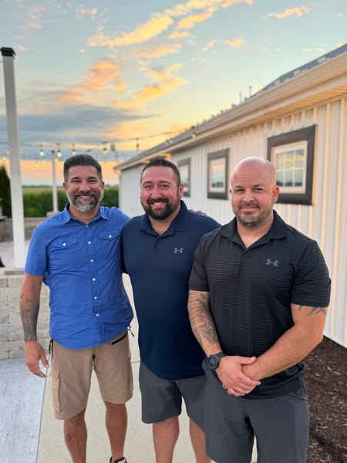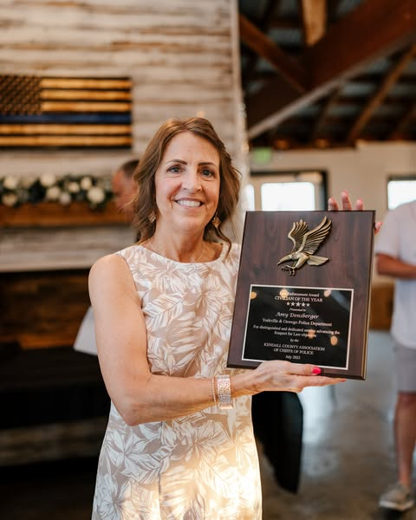

Facebook Post (7/23/25): Big News! The Yorkville Police Department is now Illinois Law Enforcement Accredited!
A huge milestone that shows our commitment to excellence, transparency, and serving our community with pride.
Thank you to Retired Chief Marc Maton, the Illinois Association of Chiefs of Police, Mayor Purcell, and the Yorkville City Council for your support.
A special shoutout to Deputy Chief Ray Mikolasek for leading this effort. Ray, we watched your effort every day while you championed this effort for our agency, that was no small task, my sincerest thank you.
As Chief—and as a Yorkville resident—I’m honored to serve alongside these outstanding men and women every single day. #YorkvilleProud #ILAccreditation #ProfessionalPolicing
- Chief James Jensen

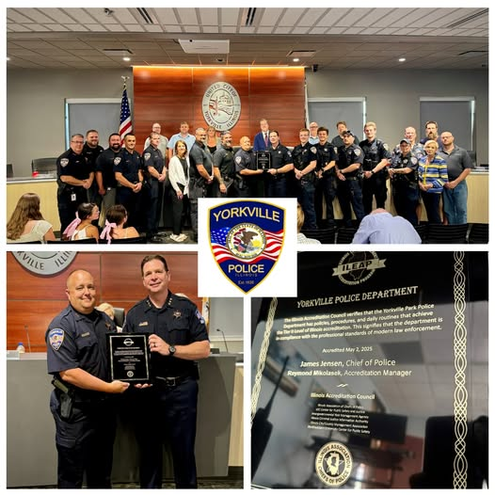
Facebook Post (7/24/25): Tuesday night was a fun night for YPD, not only did we have the honor of celebrating our state accreditation, additionally our outstanding investigations unit received Distinguished Service Awards for their efforts on a recent Murder for Hire investigation. Cases like this are extremely rare - truly a once in a lifetime investigation. The team set aside their personal lives to work straight through until they were able to arrest the individual on multiple class x felonies and ensure our citizen when home safely.
Gentlemen, Yorkville is proud of you. You’ve handled several complicated cases recently and you’ve handled them like the professionals you are! Congratulations to Detective Sergeant Nelson, Detective Ketchmark, Detective Johnson, School Resource Officer Goldsmith, AND Deputy Chief Mikolasek (you may have skipped the photo, but you know we were still going to get you! thank you for your guidance during the investigation.)

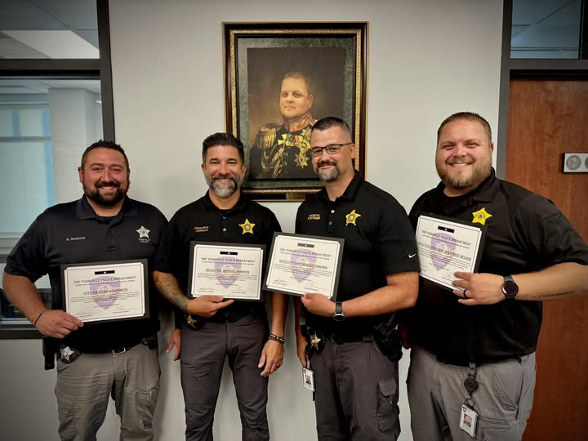

Facebook Post (7/25/25): We are grateful for our continued partnership with the Kendall County State's Attorney's Office. Check out their recent release on the successful prosecution of a case led by our very own Detective Ketchmark. Great work by everyone involved in bringing this case to a strong close!

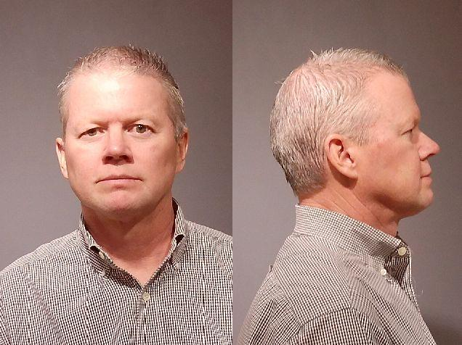

Facebook Post (7/28/25): Throughout the year, we’re proud to support our friends and partners at Special Olympics Illinois. While events like the Polar Plunge and Cop on a Rooftop are familiar favorites, this summer we’re hitting the track for something new — “FIVE-0 Racing” at the Grundy County Speedway!
First responders from all over are suiting up to see who can go fast - turn left - repeat — all for a great cause, all proceeds go directly to Special Olympics Illinois. This year, Officer Kyle Davis is representing YPD and plans on showing the field how to do it! Come join us in cheering Officer Davis this Saturday, August 2nd in Morris, IL.
Check out his fundraising page here: support.soill.org/fundraiser/6506117
Have fun, Kyle! Raise some money, make us proud, and remember…
“If you ain’t first, you’re last.” — Ricky Bobby Inc.™

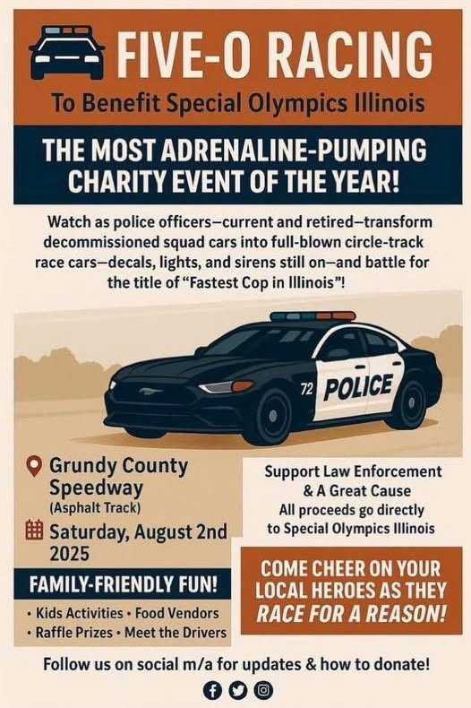

Facebook Post (7/31/25): Happy Thursday to our Yorkville community. National Night Out is around the corner, we thought we would invite everyone via emoji, so here goes....
Come (chill) with (Yorkville P.D.) and (have fun) at National Night Out. It will be(a blast) and we look forward to (interacting) with our (community). Maybe you can also (teach) us how to use (emojis) the (proper) way!


COMMUNITY PRESENTATIONS / MEETINGS
Date | Group | Officers | Topic
07/02/25 | Cedarhurst | Chief Jensen | Coffee w/ Cop
07/02/25 | Village of Oswego | Chief Jensen | Meeting
07/03/25 | Public Safety | Chief Jensen | Meeting
07/04/25 | 4th of July Park Celebration | Command Staff | Special Event
07/05/25 | Restore Church – 4th of July Freedom Celebration | Chief Jensen  Sgt. Hayes | Special Event
07/07/25 | Department Heads | Chief Jensen | Meeting
07/07/25 | Career Development | Chief Jensen | Meeting
07/08/25 | Command Meeting | Command Staff | Meeting
07/08/25 | Department Heads | Chief Jensen | Meeting
07/08/25 | City Council | Chief Jensen | Meeting
07/09/25 | Community Meeting | Chief Jensen | Meeting
07/09/25 | Career Development | Chief Jensen | Meeting
07/09/25 | Yorkville School District | Chief Jensen | Meeting
07/10/25 | Kendall County Health Dept. | Chief Jensen  Ofc. Goldsmith | Community Partnership Assessment
07/10/25 | Bristol Kendall Fire | Command Staff | Awards Ceremony
07/10/25 | Kendall CPAT /SAO | DC Mikolasek | Meeting
07/11/25 | Department Heads | DC Mikolasek | Meeting
07/15/25 | Firearms Demonstration | Command Staff | Meeting
07/15/25 | Command | Command Staff  Firearms Training Team | Meeting
07/16/25 | KenCom Operations | DC Mikolasek | Meeting
07/16/25 | Chamber Network Night | Chief Jensen | Special Event
07/18/25 | Fox Hill Senior Center | Chief Jensen | Meeting
07/18/25 | Respect for Law Banquet | Department | Special Event
07/21/25 | Department Head | Chief Jensen | Meeting
07/22/25 | BFPC | DC Mikolasek | Meeting
07/22/25 | Command | Command Staff | Meeting
07/22/25 | Citizen Meeting | Chief Jensen | Meeting
07/22/25 | Chamber Event | Chief Jensen | Special Event
07/22/25 | Department Heads | Chief Jensen | Meeting
07/22/25 | City Council | Chief Jensen | Meeting
07/23/25 | Cedarhurst | Dayshift | Coffee w/ Cop
07/23/25 | Building Tour | Chief Jensen | Tour
07/25/25 | BKFD | Command Staff | Meeting
07/25/25 | Ready Set Rescue | Chief Jensen | Meeting
07/28/25 | Department Heads | Chief Jensen | Meeting
07/29/25 | Command | Command Staff | Meeting
07/30/25 | NEMRT Advisory Board | Chief Jensen | Meeting
07/31/25 | Pre-Development 7-Brew | Command Staff | Meeting
07/31/25 | BFPC | DC Mikolasek | Meeting

TRAINING AND CAREER DEVELOPMENT
Date | Topic | Attendees | Hours
07/01/25 | A Review of Use of Force Laws | Chief Jensen  DC Carlyle  Sgt Stroup  Det Ketchmark  Ofc Kolowski | .5  .5  .5  .5  .5
07/02/25 | A Review of Use of Force Laws | 6 officers | 3
07/02/25 | Sexual Harassment Prevention | Ofc Schwartz | .5
07/02/25 | Child Abuse and Neglect | Ofc Gerlach  Ofc Heiser  Ofc Schwartz  Ofc Wade | 2  2  2  2
07/03/25 | A Review of Use of Force Laws | Sgt Hayes  Ofc Mertes  Ofc Shepherd  Ofc Warren | .5  .5  .5  .5
07/06/25 | A Review of Use of Force Laws | Ofc Borowski | .5
07/06/25 | Firearms Restraining Order Act | Ofc Kolowski | 1
07/07/25 | Sexual Harassment Prevention | Det Sgt Nelson  Chuck Davis | .5  .5
07/07/25 | Firearms Restraining Order Act | Chief Jensen | 1
07/08/25 | Child Abuse and Neglect | Ofc Davis | 2
07/09/25 | Child Abuse and Neglect | Ofc Johnson | 2
07/09/25 | A Review of Use of Force Laws | Ofc Johnson | .5
07/10/25 | A Review of Use of Force Laws | Commander McMahon  Ofc Swanson | .5  .5
07/10/25 | De-Escalation Strategies | Ofc Heiser | 16
07/11/25 | OC Spray Instructor | Ofc Reyes | 8
07/12/25 | Pension Trustee Training | Sgt Hunter | 4
07/13/25 | A Review of Use of Force Laws | Sgt Hunter | .5
07/14/25 | Proactive Patrol Tactics | Ofc Camis | 16
07/15/25 | A Review of Use of Force Laws | DC Mikolasek | .5
07/18/25 | Tactical Rifle & Pistol | Ofc Mertes | 8
07/18/25 | A Review of Use of Force Laws | Ofc Kuehlem  Ofc Reyes  Ofc Tickel | .5  .5  .5
07/18/25 | Child Abuse and Neglect | Ofc Tickel | 2
07/19/25 | Handgun Red Dot Optic Instructor | Of Shepherd | 16
07/21/25 | Emergency Vehicle Operator Trainer | Ofc Davis | 40
07/21/25 | LEADS Security and Privacy | Ofc Warren | 1
07/21/25 | LEADS Certification | Ofc Warren | 2
07/21/25 | A Review of Use of Force Laws | Det Johnson  Ofc Soebbing | .5  .5
07/22/25 | LEADS Security and Privacy | Det Sgt Nelson | 1
07/22/25 | LEADS Certification | Det Sgt Nelson | 2
07/22/25 | Stop Stick Training | Ofc Johnson  Ofc Wade | 2.5  2.5
07/23/25 | Property and Evidence Room Best Practices | Amy Densberger | 2
07/23/25 | A Review of Use of Force Laws | Ofc Camis  Ofc Heiser | .5  .5
07/23/25 | Motorcycle Gang Update | Ofc Gerlach  Ofc Shepherd | 8  8
07/24/25\] | A Review of Use of Force Laws | Ofc Schwartz  Ofc Shapiama | .5  .5
07/24/25 | Sexual Harassment Prevention | CSO Vargas | .5
07/25/25 | Sexual Harassment Prevention | Crystal Bieritz | .5
07/28/25 | Background Investigations | Det Sgt Nelson  SRO Schwartz | 8  8
07/28/25 | A Review of Use of Force Laws | Det Sgt Nelson | .5
07/29/25 | Practical Patrol Rifle | Ofc Mertes | 8
07/29/25 | Sexual Harassment Prevention | Ofc Davis | .5
07/30/25 | A Review of Use of Force Laws | Ofc Davis | .5
07/31/25 | Dale Anderson Court-Smart | Sworn Staff | 66
 |  | TOTAL | 262
TRAFFIC CRASH SUMMARY
Total Traffic Crash Reports for July 2025: 47
Total Crash Report Short Form Private Property July 2025: 5
Total Crashes for the Month of July 2025 (excluding private prop): 42

Hit & Run Crashes: 4
Personal Injury Crashes: 6 Property Damage Crashes: 36
Fatality Crashes: 0

TOP TRAFFIC CRASH INTERSECTIONS
Crash Intersection | Total Number of Crashes | Primary Contributory Causes
Route 47/ Route 126 | 6 | Following too Closely
Route 34/ Eldamain Rd. | 5 | Failure to Yield; Following too Closely; Failure to Reduce Speed; Distraction inside Vehicle
Route 47/ Galena Rd. | 3 | Under the Influence, Unable to Determine; Failure to Reduce Speed

Crash by DAY of the Week | Number of Crashes
Monday | 3
Tuesday | 9
Wednesday | 6
Thursday | 6
Friday | 4
Saturday | 8
Sunday | 6

Crash by TIME of Day | Number of Crashes
0600-0959 | 5
1000-1359 | 7
1400-1759 | 16
1800-2159 | 9
2200-0159 | 3
0200-0559 | 2

TRAFFIC COMPLAINT / ENFORCEMENT INFORMATION
In July 2025, the Yorkville Police Department had received traffic concerns for various locations in town. These concerns were established through both citizen concerns and areas of concern for the department. All citizen concerns were tracked for potential issues. In some cases to verify that the concerns needed to be further addressed, (5) five years of crash data was researched. In addition, these locations were further researched by utilizing the department’s speed signs. These speed signs were able to collect traffic data related to traffic counts, speed data, and various times of day of violations. In addition, the department also relied upon its partnership with EEI.

TRAFFIC CONCERNS
Month | Number of Concerns | Speed | Stop Sign | Parking | Disobey Traffic Control Device | Abandoned Auto | Cell Phone | Other
January | 2 | 1 | 0 | 0 | 0 | 0 | 0 | 1
February | 0 | 2 | 0 | 4 | 0 | 0 | 0 | 0
March | 1 | 1 | 0 | 0 | 0 | 0 | 0 | 0
April | 2 | 0 | 0 | 0 | 1 | 0 | 0 | 1
May | 1 | 0 | 1 | 0 | 0 | 0 | 0 | 0
June | 4 | 4 | 0 | 0 | 0 | 0 | 0 | 0
July | 4 | 1 | 0 | 1 | 0 | 0 | 0 | 2
Total | 14 | 9 | 1 | 5 | 1 | 0 | 0 | 4
Note: Some months have more than one concern or may have a repeated concern related to a specific location.

SPEED DATA
The Yorkville Police Department utilized the YPD Speed Signs to collect traffic and speed data to help research a particular traffic concern. Below are the results:

Dates of Deployment | Location | Type of Concern | Additional
June/July | Raintree | Speed | Follow Up
June/July | Greenbriar | Speed | New
June/July | Cannonball: Blackberry Woods | Speed | New

PORTABLE SPEED SIGN RESULTS
Speed Sign Location | Dates | Speed Limit | Avg Speed | 85th Percentile | Max Speeds | 11-15 mph | 16+ mph | Daily Avg | Total Vehicles | Focused Times
Raintree / Kingsmill SB | 06-27-2025 to 07-04-2025 | 30 | 25.28 | 31.45 | 46-50 x2 | 21 | 2 | 965 | 7,720 | N/A
Raintree / Sunnydell NB | *07-06-2025 to 07-22-2025 | 30 | 27.75 | 33.4 | 61-65 x1 | 76 | 17 | 654 | 8,805 | N/A
Cannonball / N Carly SB | 06-27-2025 to 07-04-2025 | 30 | 23.64 | 31.36 | 56-60 x1 | 24 | 7 | 769 | 6,159 | N/A
Cannonball / N Carly NB | 07-06-2025 to 07-20-2025 | 30 | 21.26 | 28.28 | 46-50 x1 | 10 | 1 | 438 | 6,574 | N/A
Greenbriar / Cornerstone WB | 06-27-2025 to 07-04-2025 | 40 | 31.94 | 40.47 | 76-80 x3 | 90 | 53 | 2,395 | 19,166 | N/A
Greenbriar / Route 47 EB | 07-06-2025 to 07-20-2025 | 40 | 34.25 | 40.76 | 66-70 x3 | 140 | 41 | 2,175 | 32,635 | N/A
*07-10-2025 to 07-13-2025 Out of Service
“85th Percentile Speed (mph) – The 85th percentile speed is the speed at or below which 85 percent of the drivers travel on a road segment. Motorists traveling above the 85th percentile speed are considered to be exceeding the safe and reasonable speed for road and traffic conditions.” (Illinois Department of Transportation)

SPEED DATA CONTINUED
Location | Direction | 11-15mph over and 16+mph | Total Vehicles | % of Vehicles 11+mph over
Raintree / Kingsmill | SB | 23 | 7,720 | 0.29%
Raintree / Sunnydell | NB | 93 | 8,805 | 1.05%
Cannonball / N Carly | SB | 31 | 6,159 | 0.50%
Cannonball / N Carly | NB | 11 | 6,574 | 0.16%
Greenbriar / Cornerstone | WB | 143 | 19,166 | 0.74%
Greenbriar / Route 47 | EB | 181 | 32,635 | 0.55%

MONITORED PATROL DETAIL DATA
During July 2025 a total of 2 Monitored Locations and 4 Monitored Follow Up Locations, which were areas that have not been confirmed at the time to be Directed Patrol Locations which were completed by Community Service Officers (CSO), as well as Yorkville Police Officers, for tentative Directed Patrol Locations. Additionally, when there are no new locations, CSOs assist by monitoring established Directed Patrol Locations.

Location | Date | Concern | Number of Details | Total Time (Hours) | Citations | Warnings | Courtesy Notices
Berrywood | July | Speed | 1 | 0.25 | 0 | 1 | 0
*Bristol Ridge | July | Speed/Stop | 3 | 2.75 | 0 | 7 | 0
*E Galena | July | Speed | 1 | 0.25 | 0 | 1 | 0
*E Van Emmon | July | Speed | 2 | 3 | 1 | 2 | 0
*McHugh | July | Speed/Stop | 3 | 2.5 | 0 | 2 | 1
Orange/Mill | July | Stop | 1 | 0.75 | 0 | 0 | 4
Total | July | N/A | 11 | 9.5 | 1 | 13 | 5
*Follow Up

DIRECTED PATROLS
During the July 2025, a total of 6 Directed Patrols were completed by members of the Yorkville Police Department. Directed Patrols are a result of complaints received and substantiated based off the following criteria: monitoring traffic, traffic count studies or speed studies.

Downtown
 | Speed | Lane Use | Turning | Traffic Control Device | Seatbelt | Other Moving | Cell Phone Usage | Non- Moving | Totals
Citations | 0 | 0 | 0 | 0 | 0 | 0 | 0 | 5 | 5
Warnings | 15 | 0 | 0 | 0 | 0 | 0 | 0 | 4 | 19
Total | 15 | 0 | 0 | 0 | 0 | 0 | 0 | 9 | 24

 | DUI | DWLS/DWLR | NO  Valid  DL | Warrant | Drugs | Weapons | Other | Totals
Arrests | 0 | 0 | 0 | 0 | 0 | 0 | 0 | 0

Route 126
 | Speed | Lane Use | Turning | Traffic Control Device | Seatbelt | Other Moving | Cell Phone Usage | Non- Moving | Totals
Citations | 0 | 0 | 0 | 0 | 0 | 0 | 0 | 0 | 0
Warnings | 1 | 0 | 0 | 0 | 0 | 0 | 0 | 0 | 1
Total | 1 | 0 | 0 | 0 | 0 | 0 | 0 | 0 | 0

 | DUI | DWLS/DWLR | NO  Valid  DL | Warrant | Drugs | Weapons | Other | Totals
Arrests | 0 | 0 | 0 | 0 | 0 | 0 | 0 | 0

Route 34
 | Speed | Lane Use | Turning | Traffic Control Device | Seatbelt | Other Moving | Cell Phone Usage | Non- Moving | Totals
Citations | 5 | 0 | 0 | 1 | 0 | 1 | 0 | 9 | 16
Warnings | 65 | 0 | 0 | 2 | 0 | 9 | 0 | 45 | 121
Total | 70 | 0 | 0 | 3 | 0 | 10 | 0 | 54 | 137

 | DUI | DWLS/DWLR | NO  Valid  DL | Warrant | Drugs | Weapons | Other | Totals
Arrests | 1 | 3 | 1 | 0 | 0 | 0 | 0 | 5

Route 47
 | Speed | Lane Use | Turning | Traffic Control Device | Seatbelt | Other Moving | Cell Phone Usage | Non- Moving | Totals
Citations | 6 | 0 | 0 | 0 | 0 | 1 | 0 | 6 | 13
Warnings | 47 | 2 | 0 | 8 | 0 | 7 | 2 | 38 | 104
Total | 53 | 2 | 0 | 8 | 0 | 8 | 2 | 44 | 117

 | DUI | DWLS/DWLR | NO  Valid  DL | Warrant | Drugs | Weapons | Other | Totals
Arrests | 0 | 1 | 0 | 0 | 2 | 0 | 0 | 3

Route 71
 | Speed | Lane Use | Turning | Traffic Control Device | Seatbelt | Other Moving | Cell Phone Usage | Non- Moving | Totals
Citations | 8 | 0 | 0 | 0 | 0 | 0 | 0 | 4 | 12
Warnings | 37 | 0 | 0 | 0 | 0 | 0 | 0 | 12 | 49
Total | 45 | 0 | 0 | 0 | 0 | 0 | 0 | 16 | 61

 | DUI | DWLS/DWLR | NO  Valid  DL | Warrant | Drugs | Weapons | Other | Totals
Arrests | 0 | 1 | 0 | 0 | 0 | 0 | 0 | 1

W. Fox Street
 | Speed | Lane Use | Turning | Traffic Control Device | Seatbelt | Other Moving | Cell Phone Usage | Non- Moving | Totals
Citations | 0 | 0 | 0 | 0 | 0 | 0 | 0 | 0 | 0
Warnings | 30 | 0 | 0 | 0 | 0 | 0 | 0 | 1 | 31
Total | 30 | 0 | 0 | 0 | 0 | 0 | 0 | 1 | 31

 | DUI | DWLS/DWLR | NO  Valid  DL | Warrant | Drugs | Weapons | Other | Totals
Arrests | 0 | 0 | 0 | 0 | 0 | 0 | 0 | 0

DIRECTED PATROL DETAIL DATA
Location | Dates | Number of Details | Total Time (Hours) | Number of Traffic Stops
Downtown | July 2025 | 12 | 13.07 | 22
Route 126 | July 2025 | 2 | 1.5 | 1
Route 34 | July 2025 | 43 | 81.09 | 130
Route 47 | July 2025 | 44 | 80.07 | 115
Route 71 | July 2025 | 26 | 35.25 | 57
W Fox Street | July 2025 | 10 | 12.75 | 26
Total | July 2025 | 137 | 223.73 | 351

TRAFFIC ENFORCEMENT
Citations | Total 2025 | July 2024 | July 2025
Speeding | 124 | 8 | 39
No Insurance | 99 | 13 | 28
Seatbelt | 2 | 0 | 0
Other Violations | 267 | 28 | 88
Total | 492 | 49 | 155

Warnings | Total 2025 | July 2024 | July 2025
Speeding | 2,116 | 233 | 258
No Insurance | 155 | 32 | 20
Seatbelt | 5 | 0 | 1
Other Violations | 1,013 | 105 | 168
Miscellaneous/Parking | 1,186 | 208 | 138
Total | 4,475 | 578 | 585

DETECTIVE SQUAD
On July 11th, Detective Ketchmark was able to obtain an arrest warrant for Tricia Vida for four counts of felony theft (Class 2 Felonies) regarding her actions as an employee at a business located on Boombah Drive in Yorkville. This warrant was issued after an extensive investigation completed by Detective Ketchmark, that began in October of 2024. Vida was arrested on her warrant and is currently awaiting trial.

On July 29th, the Investigations Unit was able to secure charges against Lindsay Facer regarding her involvement with the April of 2025 Murder for Hire investigation. Facer was charged with, and plead guilty too, one count of Attempted Solicitation of Murder (Class 1 felony) and one count of Criminal Trespass to Residence (Class A misdemeanor). These charges stemmed from the continued investigation into the Murder for Hire investigation that began in April of 2025 and ultimately charges Mark Hellenthal with Solicitation for Murder and Solicitation for Murder for Hire.

Cases Assigned (Criminal)  Cases in which a crime has been committed | Total 2025 | July 2024 | July 2025
Adult | 44 | 10 | 4
Juvenile | 25 | 0 | 0
Total | 69 | 9 | 4

Cases Assigned (Non-Criminal)  Non-Criminal Cases are closed w/in 7 days. | Total 2025 | July 2024 | July 2025
Sex Offender (registration, misc. contact) | 24 | 5 | 4
Death Investigations | 5 | 3 | 0
FOID / CCL Turn-In | 15 | 2 | 3
Assist Other Police / Govt Agency | 6 | 6 | 1
Assist Schools | 0 | 0 | 0
Missing Persons | 3 | 0 | 2
Traffic Crash | 2 | 0 | 0
Background Investigations | 142 | 38 | 13
Total | 198 | 54 | 23

Total Cases Assigned | Total 2025 | July 2024 | July 2025
Adult | 44 | 10 | 4
Juvenile | 25 | 0 | 0
Non-Criminal | 198 | 55 | 23
Total | 267 | 65 | 27

Criminal Cases Closed | Total 2025 | July 2024 | July 2025
Adult | 51 | 10 | 10
Juvenile | 26 | 3 | 1
Total | 77 | 13 | 11

Total Arrests | Total 2025 | July 2024 | July 2025
Adult | 10 | 1 | 3
Juvenile | 28 | 1 | 0
Total | 38 | 2 | 3

Evidence | Total 2025 | July 2024 | July 2025
Items Recovered | 59 | 50 | 65
Items Destroyed or Returned | 4 | 2 | 16

SCHOOL RESOURCE OFFICER ACTIVITY
Activity | July 2025 | YTD 2025
Criminal Report(s) | 0 | 16
Non-Criminal Report(s) | 0 | 15
Criminal Arrests | 0 | 23
City Ordinance Violation(s) | 0 | 8
Classroom Engagement | 0 | 21
Student Counseling/Outreach | 0 | 142
Parental Engagement | 0 | 83
Threat Assessment(s) | 0 | 1
Extra-Curricular Event(s) | 0 | 1
TOTAL | 0 | 310

CRIME REPORTING
The Police Department volume of law enforcement activity during the reporting period is demonstrated by category in the table below. The data includes activity reported to the State of Illinois monthly through the National Incident-Based Reporting System (NIBRS) as well as all other criminal and quasi-criminal activity that is not required to be reported to the State. For comparison purposes, the statistical reporting from the same reporting period one year ago is included. NOTE: This data is insufficient for use in establishing trends, assessing workload distribution or any other statistical analysis. Further data, delving beyond this report, is essential in determining accurate and meaningful insight beyond this report.

REPORTS
 | July 2024 | July 2025 | Total  2024 | Total  2025
Criminal Reports | 60 | 102 | 768 | 441
Non-Criminal Reports | 57 | 61 | 823 | 375
Sex Offender Registration | 1 | 1 | 17 | 10
911 (Hang-up, Misdial, Open Line) | 57 | 74 | 598 | 305
Motorist Assist | 29 | 38 | 514 | 217
Lockouts (vehicle, residential, business) | 24 | 20 | 269 | 122
Accident / Property Damage | 35 | 36 | 406 | 193
Accident / Personal Injury | 5 | 6 | 79 | 29
Accident / Fatal | 0 | 0 | 3 | 1
Accident / Hit & Run | 3 | 4 | 44 | 28
Accident / Private Property | 9 | 5 | 124 | 47
D.U.I Reports | 2 | 6 | 41 | 23
Total | 282 | 353 | 3,686 | 1,791

Offense Summary (NIBRS)
Crimes Against Persons | July  2024 |  | July  2025 |  | YTD  2024 | YTD  2025
Assault Offenses | 13 |  | 18 |  | 88 | 112
Homicide Offenses | 0 |  | 0 |  | 0 | 0
Human Trafficking Offenses | 0 |  | 0 |  | 0 | 0
Kidnapping/Abduction | 0 |  | 0 |  | 0 | 0
Sex Offenses | 1 |  | 1 |  | 18 | 9
Total Crimes Against Persons | 14 |  | 19 |  | 106 | 121
Crimes Against Property | July  2024 | July  2025 |  | YTD  2024 |  | YTD  2025
Arson | 0 | 0 |  | 0 |  | 0
Bribery | 0 | 0 |  | 1 |  | 0
Burglary/Breaking and Entering | 1 | 2 |  | 8 |  | 5
Counterfeiting/Forgery | 4 | 0 |  | 12 |  | 1
Destruction/Damage/Vandalism | 5 | 8 |  | 20 |  | 32
Embezzlement | 0 | 0 |  | 0 |  | 0
Extortion/Blackmail | 0 | 0 |  | 0 |  | 0
Fraud Offenses | 1 | 6 |  | 37 |  | 31
Larceny/Theft Offenses | 8 | 25 |  | 48 |  | 68
Motor Vehicle Theft | 0 | 0 |  | 1 |  | 0
Robbery | 0 | 0 |  | 0 |  | 0
Stolen Property Offenses | 0 | 0 |  | 1 |  | 0
Total Crimes Against Property | 19 | 41 |  | 128 |  | 137
Crimes Against Society | July  2024 | July  2025 |  | YTD  2024 |  | YTD  2025
Animal Cruelty | 0 | 0 |  | 0 |  | 0
Drug/Narcotic Offenses | 1 | 6 |  | 4 |  | 18
Gambling Offenses | 0 | 0 |  | 0 |  | 0
Pornography/Obscene Material | 0 | 1 |  | 6 |  | 3
Prostitution Offenses | 0 | 0 |  | 0 |  | 0
Weapons Law Violations | 0 | 0 |  | 1 |  | 2
Total Crimes Against Society | 1 | 7 |  | 11 |  | 23
Total Crimes | 34 | 67 |  | 245 |  | 281
CRISIS INTERVENTION CALL
 | July  2024 | Total  2024 | July  2025 | Total  2025
Mental Health/Crisis Intervention Calls | 5 | 57 | 5 | 34
Voluntary Committal | 0 | 18 | 0 | 6
Involuntary Committal | 3 | 23 | 3 | 16
Response to Resistance reference CIT Call | 0 | 0 | 1 | 3
CIT Follow Ups | 3 | 54 | 5 | 25
Citizen at Risk Registrations | 0 | 2 | 0 | 0
CAR Follow Ups | 0 | 0 | 1 | 1

PATROL ARRESTS
 | Total  2024 | July 2025 | Total 2025
Felony | 15 | 3 | 16
Misdemeanors | 287 | 59 | 190
Total | 302 | 62 | 206

CALLS FOR SERVICE
 | Jan | Feb | Mar | Apr | May | Jun | Jul | Aug | Sep | Oct | Nov | Dec | Total
2025 | 1390 | 1238 | 1583 | 1490 | 1608 | 1398 | 1647 | - | - | - | - | - | 10,354
2024 | 1495 | 1371 | 1423 | 1467 | 1446 | 1457 | 1423 | 1380 | 1344 | 1430 | 1326 | 1291 | 16,853
2023 | 1145 | 994 | 1061 | 1018 | 1164 | 1082 | 1229 | 1017 | 1066 | 1048 | 1097 | 980 | 12,901
2022 | 1131 | 930 | 1149 | 1198 | 1344 | 1191 | 1346 | 1082 | 1176 | 1149 | 915 | 927 | 13,538
2021 | 1156 | 1102 | 1129 | 977 | 1068 | 1224 | 1228 | 1118 | 1190 | 1116 | 1101 | 1041 | 13,450

VEHICLE USE & EXPENSES
SQUAD CAR OPERATION EXPENSES
 | July 2024 | July 2025
Monthly Mileage | 22,600 | 20,959
Gasoline Expense | $7,691.93 | $6,751.37
Gallons of Gasoline | 2,019.16 | 1,930.03
Maintenance Expense | $6,610.39 | $486.70
Cost Per Gallon | $3.809 | $3.498
Cost Per Mile (Gasoline & Maintenance Costs Included) | $0.632 | $0.345

VEHICLE USAGE AND EXPENSES
Squad # | Vehicle Year  Model | Assigned | Beginning Mileage | Ending Mileage | Monthly Miles
M-1 | 2023  Explorer | Patrol | 21,397 | 22,192 | 795
M-2 | 2020 Explorer | Investigations | 101,575 | 101,987 | 412
M-3 | 2016  Impala | Deputy Chief | 92,867 | 93,242 | 375
M-4 | 2021  Explorer | Patrol | 101,725 | 104,240 | 2,515
M-5 | 2016  Impala | Training | 97046 | 97,046 | 0
M-7 | 2021 Explorer | Patrol | 88,008 | 89,517 | 1,509
M-8 | 2016  Impala | Chief | 44,590 | 45,170 | 580
M-9 | 2023  Explorer | Patrol | 6125 | 6,283 | 158
M-10 | 2016  Impala | Patrol | 84,119 | 84,351 | 232
M-11 | 2016  Impala | Investigations | 90,561 | 91,509 | 948
M-12 | 2021 Explorer | Patrol | 69,873 | 72,396 | 2,523
M-13 | 2016  Impala | CSO | 97,251 | 97,320 | 69
M-14 | 2021  Explorer | Patrol | 64,108 | 65,912 | 1,804
M-15 | 2022 Explorer | Sergeant | 40,913 | 42,187 | 1,274
M-16 | 2023  Explorer | Patrol | 10,707 | 11,626 | 919
M-17 | 2016  Impala | Commander | 59,040 | 59,708 | 668
M-19 | 2023  Explorer | Patrol | 8,193 | 8,923 | 730
M-20 | 2016  Impala | Investigations | 81,349 | 81,611 | 262
M-21 | 2016  Impala | CSO | 90,108 | 90,339 | 231
M-22 | 2023 Explorer | Patrol | 42,643 | 43,452 | 809
M-23 | 2018  Malibu | Deputy Chief | 38,728 | 39,492 | 764
M-24 | 2022 Explorer | Patrol | 43,051 | 44,965 | 1,914
M-25 | 2022 Explorer | Patrol | 46,178 | 47,646 | 1,468


651 Prairie Pointe Dr
Yorkville, IL 60560

